Java - Introduction to Programming
Lecture 6

Patterns - Part 2

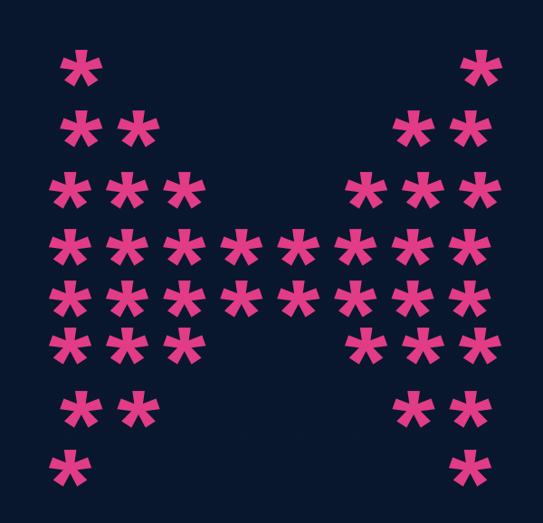

import java.util.*;

public class Solutions {
public static void main(String args[]) {
int n = 4;

//upper part
for(int i=1; i<=n; i++) {
for(int j=1; j<=i; j++) {
System.out.print("*");
}

int spaces = 2 * (n-i);
for(int j=1; j<=spaces; j++) {
System.out.print(" ");
}

for(int j=1; j<=i; j++) {
System.out.print("*");
}
System.out.println();
}

//lower part
for(int i=n; i>=1; i--) {
for(int j=1; j<=i; j++) {
System.out.print("*");
}

int spaces = 2 * (n-i);
for(int j=1; j<=spaces; j++) {
System.out.print(" ");
}

for(int j=1; j<=i; j++) {
System.out.print("*");
}
System.out.println();
}
}
}

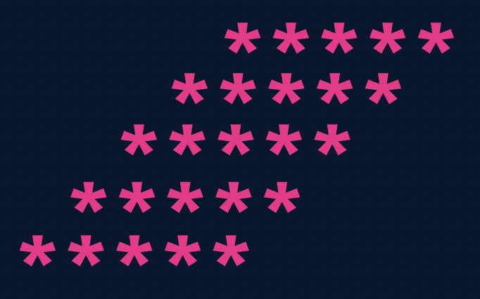

import java.util.*;

public class Solutions {
public static void main(String args[]) {
int n = 5;

for(int i=1; i<=n; i++) {
//spaces
for(int j=1; j<=n-i; j++) {
System.out.print(" ");
}

//stars
for(int j=1; j<=n; j++) {
System.out.print("*");
}
System.out.println();
}
}
}

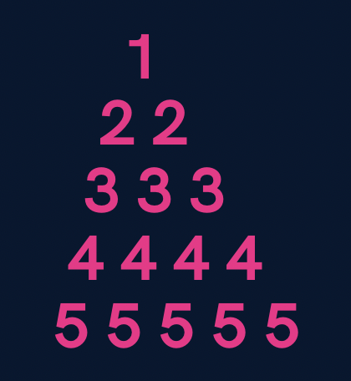

import java.util.*;

public class Solutions {
public static void main(String args[]) {
int n = 5;

for(int i=1; i<=n; i++) {
//spaces
for(int j=1; j<=n-i; j++) {
System.out.print(" ");
}

//numbers
for(int j=1; j<=i; j++) {
System.out.print(i+" ");
}
System.out.println();
}
}
}

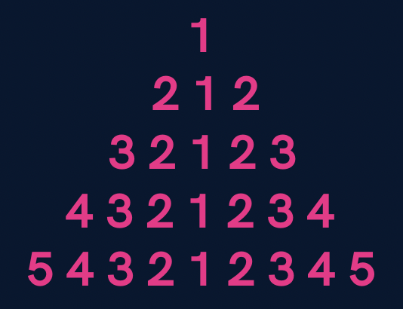

import java.util.*;

public class Solutions {
public static void main(String args[]) {
int n = 5;
for(int i=1; i<=n; i++) {
//spaces
for(int j=1; j<=n-i; j++) {
System.out.print(" ");
}

//first part
for(int j=i; j>=1; j--) {
System.out.print(j);
}

//second part
for(int j=2; j<=i; j++) {
System.out.print(j);
}
System.out.println();
}
}
}
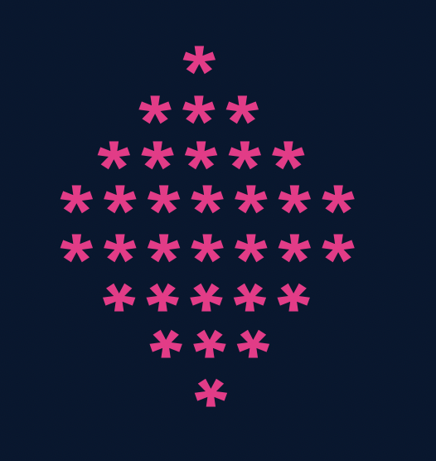

import java.util.*;

public class Solutions {
public static void main(String args[]) {
int n = 5;

//upper part
for(int i=1; i<=n; i++) {
//spaces
for(int j=1; j<=n-i; j++) {
System.out.print(" ");
}
for(int j=1; j<=2*i-1; j++) {
System.out.print("*");
}
System.out.println();
}

//lower part
for(int i=n; i>=1; i--) {
//spaces
for(int j=1; j<=n-i; j++) {
System.out.print(" ");
}
for(int j=1; j<=2*i-1; j++) {
System.out.print("*");
}
System.out.println();
}
}
}

Homework Problems
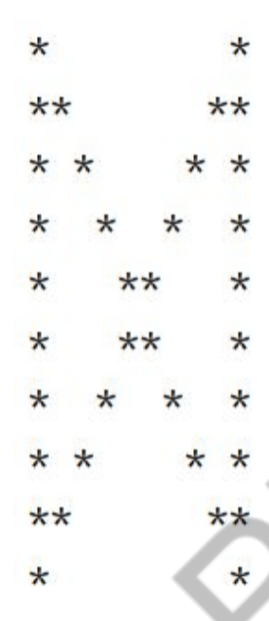
- Print a hollow Butterfly.

- Print a hollow Rhombus.
*****
* *
* *
* *
*****
- Print Pascal’s Triangle.
1
1 1
1 2 1
1 3 3 1
1 4 6 4 1
- Print half Pyramid.
1
1 2
1 2 3
1 2 3 4
1 2 3 4 5
- Print Inverted Half Pyramid.
11111
222
33
4

